Harrow Bay O&M Readiness Plan
From first power 2027 to COD 2028
David Chen · 15 April 2026 · HB-OPS-PLN-0001

1. Purpose
This plan describes how Asset Operations will be ready to operate Harrow Bay Offshore Wind (480 MW, 40 × Halden HTS-12 (12 MW), rotor diameter 236 m, hub height 140 m) from first power (planned 30 September 2027) and to take full responsibility at the commercial operation date (planned 30 June 2028). It is owned by David Chen and agreed with Elena Márquez as Project Director.

2. Operating model
Area | During warranty (COD – COD+5) | After warranty
Turbines (40 × HTS-12) | Halden Turbine Systems – warranty-period service under the turbine supply agreement (WE-CON-2025-022) | Option: long-term service agreement or ISP
Balance of plant (OSS, cables, foundations) | Weyland O&M team + specialist contractors | Same
Marine coordination | Weyland marine coordination centre at Port of Eastholm | Same
Vessels | 3 crew transfer vessels (CTV) on long-term charter; SOV decision in 2027 | Review
Remote operation | Weyland Control Centre, Edinburgh (24/7) | Same
Grid compliance | Weyland with NordGrid Transmission | Same

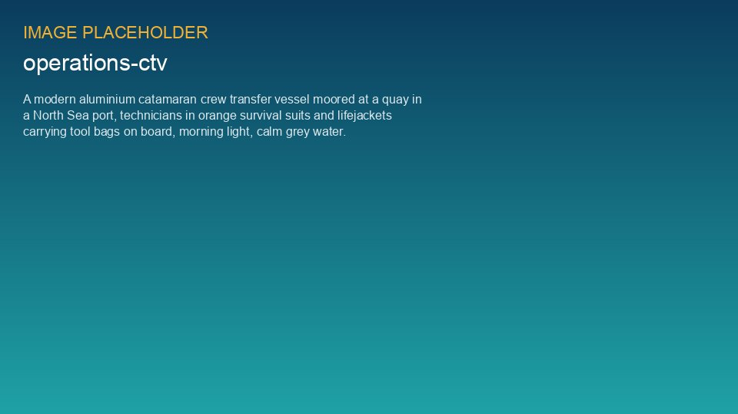
Crew transfer vessels will operate from the O&M base at Port of Eastholm

3. Readiness workstreams

